CHAPTER 16
Excretory Products and their Elimination

Animals accumulate ammonia, urea, uric acid, carbon dioxide, water and ions like Na⁺, K⁺, Cl⁻, phosphate, sulphate and others, either as by-products of their own metabolic activities or by other means such as excess ingestion. These substances have to be removed totally or partially, because allowing them to build up would poison the body fluids. This chapter deals with the mechanisms of elimination of these substances, with special emphasis on the common nitrogenous wastes.
• Excretion - the removal of metabolic waste products, especially nitrogenous wastes, from the body.
• Osmoregulation - the maintenance of a constant water and electrolyte (ionic) balance in the body fluids. Excretory organs almost always perform osmoregulation alongside waste removal, and in many invertebrates osmoregulation is the primary job.
Ammonia, urea and uric acid are the three major forms of nitrogenous waste excreted by animals. They differ in exactly one respect that matters, and every other fact about them follows from it: toxicity runs opposite to water cost. Ammonia is the most toxic form and therefore requires a large amount of water for its elimination; uric acid, being the least toxic, can be removed with a minimum loss of water. Which one an animal makes is decided mainly by its habitat, that is, by how much water it can afford to throw away.
Waste | Toxicity | Water needed | Excretory habit | Animals
Ammonia | Most toxic | Largest amount | Ammonotelism | Many bony fishes, aquatic amphibians, aquatic insects
Urea | Moderately toxic | Moderate | Ureotelism | Mammals, many terrestrial amphibians, marine fishes
Uric acid | Least toxic | Minimum loss | Uricotelism | Reptiles, birds, land snails, insects

• Ammonotelism - the process of excreting ammonia. Many bony fishes, aquatic amphibians and aquatic insects are ammonotelic in nature.
• Ammonia, as it is readily soluble, is generally excreted by diffusion across body surfaces or through gill surfaces (in fish) as ammonium ions (NH₄⁺).
• Kidneys do not play any significant role in the removal of ammonia. This is a favourite NEET distractor: ammonotelic excretion is a body-surface process, not a renal one.
Terrestrial adaptation necessitated the production of lesser toxic nitrogenous wastes like urea and uric acid, for conservation of water. Land animals cannot spare the water that ammonia disposal costs, so evolution traded toxicity for dryness.
• Ureotelism - excretion of urea. Mammals, many terrestrial amphibians and marine fishes mainly excrete urea and are called ureotelic animals.
1 | Ammonia is produced by metabolism (chiefly deamination of amino acids).
2 | It is converted into urea in the liver of these animals - the liver, not the kidney, is the site of urea synthesis.
3 | The urea is released into the blood.
4 | The blood is filtered by the kidneys and the urea is excreted out.

[NOTE] Some amount of urea may be retained in the kidney matrix of some of these animals to maintain a desired osmolarity. Urea is therefore not purely a waste to be dumped - in the mammalian kidney it is also a working solute, a point that returns in 16.4.

• Uricotelism - excretion of uric acid. Reptiles, birds, land snails and insects excrete nitrogenous wastes as uric acid in the form of pellet or paste with a minimum loss of water and are called uricotelic animals.
[MEMORY AID - not in NCERT] Toxicity ladder, most to least toxic: Ammonia > Urea > Uric acid - and the water bill falls in the same order. "A-U-U" = Aquatic - in between - Arid. Ammonotelic = water everywhere (bony fish); ureotelic = mammals; uricotelic = birds and reptiles that must fly or hoard water, hence a semi-solid pellet.

16.0 | Excretory Structures Across the Animal Kingdom

A survey of the animal kingdom presents a variety of excretory structures. In most of the invertebrates, these structures are simple tubular forms, whereas vertebrates have complex tubular organs called kidneys. Some of these structures are mentioned here.
Excretory structure | Found in | Function
Protonephridia or flame cells | Platyhelminthes (flatworms, e.g., Planaria), rotifers, some annelids and the cephalochordate - Amphioxus | Primarily ionic and fluid volume regulation, i.e., osmoregulation
Nephridia | Earthworms and other annelids | Remove nitrogenous wastes and maintain fluid and ionic balance
Malpighian tubules | Most insects, including cockroaches | Removal of nitrogenous wastes and osmoregulation
Antennal glands or green glands | Crustaceans like prawns | Perform the excretory function
Kidneys | Vertebrates, including humans | Complex tubular organs; nitrogenous waste removal plus osmoregulation and acid-base balance

[MEMORY AID - not in NCERT] Amphioxus is the exam trap. Exercise 11(a) asks for "a chordate animal having flame cells" - the answer is Amphioxus, not Planaria. Planaria is a flatworm; Amphioxus is the cephalochordate on that same list.

[NOTE] These five organ types are not merely a list to memorise. Every one of them does two jobs at once - it eliminates nitrogenous waste and helps maintain the ionic and acid-base balance of body fluids. That dual role is the single idea the human kidney then executes with far more precision in the rest of this chapter.

16.1 | HUMAN EXCRETORY SYSTEM

In humans, the excretory system consists of a pair of kidneys, one pair of ureters, a urinary bladder and a urethra (Figure 16.1).
16.1a | Position, Size and Gross Structure of the Kidney

• Kidneys are reddish brown, bean shaped structures situated between the levels of the last thoracic and third lumbar vertebra, close to the dorsal inner wall of the abdominal cavity.
• Each kidney of an adult human measures 10-12 cm in length, 5-7 cm in width, 2-3 cm in thickness, with an average weight of 120-170 g.
• Towards the centre of the inner concave surface of the kidney is a notch called hilum, through which the ureter, blood vessels and nerves enter.
• Inner to the hilum is a broad funnel shaped space called the renal pelvis, with projections called calyces.
• The outer layer of the kidney is a tough capsule (the renal capsule).
Inside the kidney there are two zones: an outer cortex and an inner medulla.
• The medulla is divided into a few conical masses - the medullary pyramids - projecting into the calyces (sing.: calyx).
• The cortex extends in between the medullary pyramids as renal columns called Columns of Bertini.
[NOTE] The kidney receives its blood through the renal artery, a branch of the dorsal aorta, and returns it through the renal vein, which drains into the inferior vena cava. Both great vessels are drawn and labelled in Figure 16.1 but are never named in the chapter's running text, so they are named here: they are the reason a kidney can filter about one-fifth of the cardiac output every minute. Sitting on top of each kidney is the adrenal gland, also labelled in Figure 16.1; its cortex supplies the aldosterone that appears in 16.5.

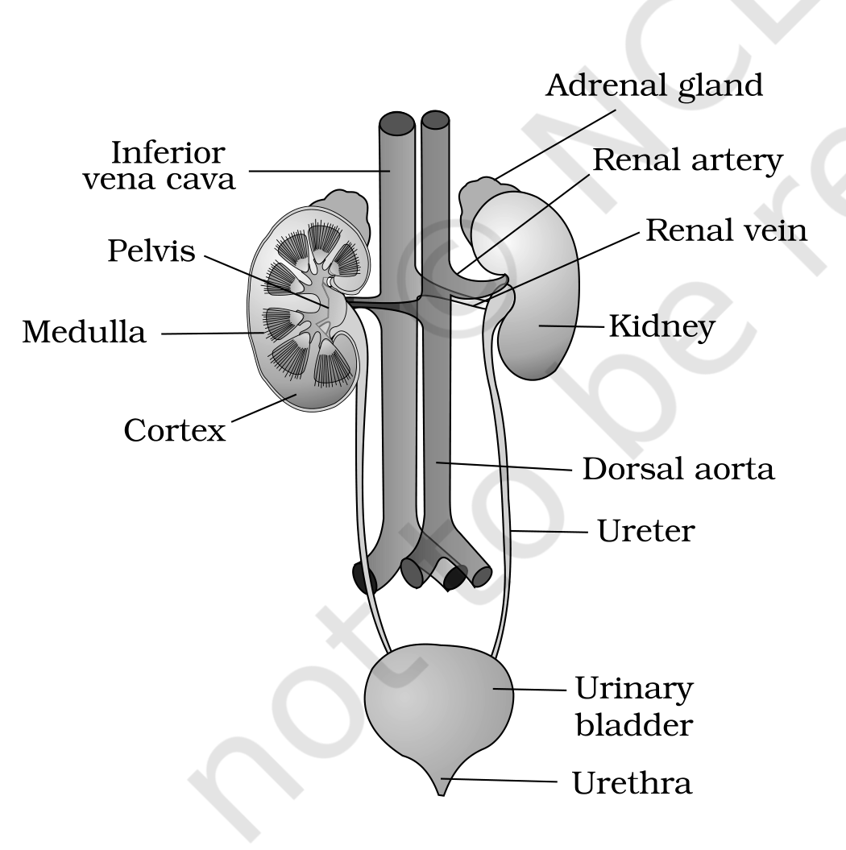 | 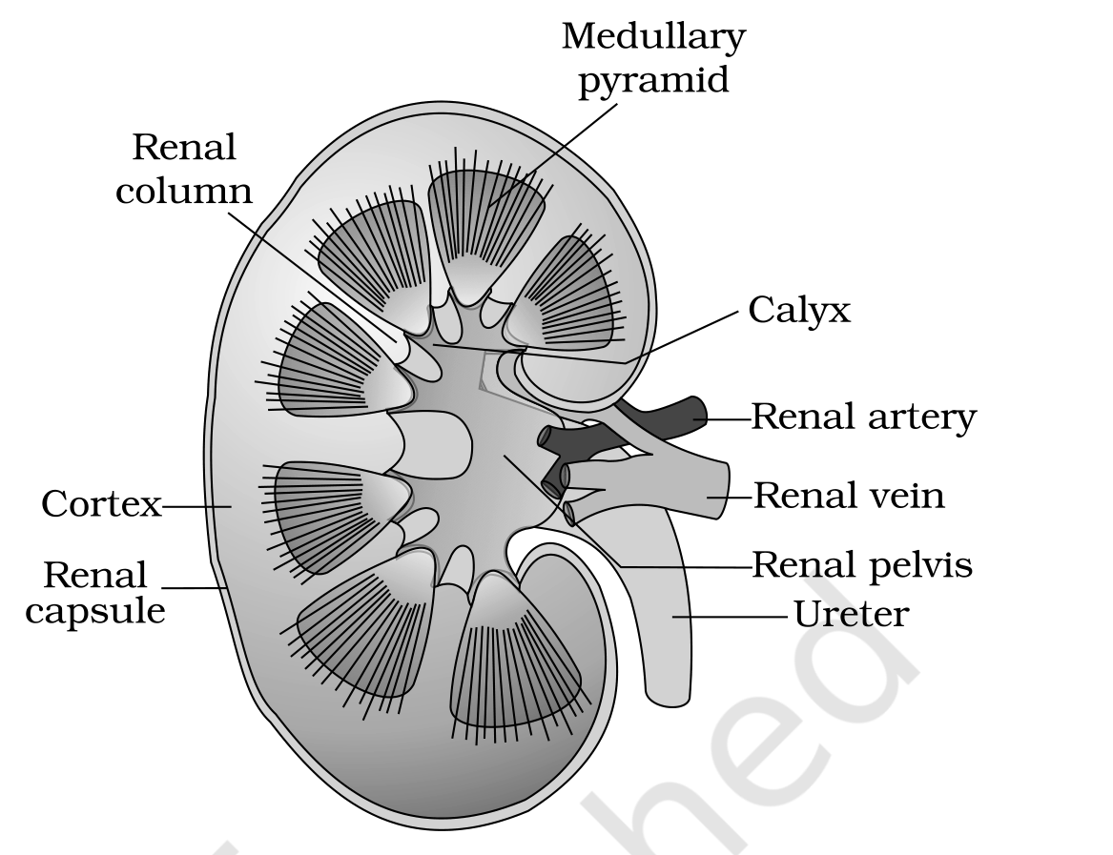

[MEMORY AID - not in NCERT] Urine's one-way road: Nephron -> Collecting duct -> Medullary pyramid -> Calyx -> Renal pelvis -> Ureter -> Urinary bladder -> Urethra. Nothing is reabsorbed after the collecting duct - once the filtrate leaves the duct it is final urine, and everything downstream is plumbing and storage only.

16.1b | The Nephron - Functional Unit of the Kidney

Each kidney has nearly one million complex tubular structures called nephrons (Figure 16.3), which are the functional units of the kidney. Each nephron has two parts - the glomerulus and the renal tubule.
• Glomerulus - a tuft of capillaries formed by the afferent arteriole, a fine branch of the renal artery. Blood from the glomerulus is carried away by an efferent arteriole.
• Malpighian body or renal corpuscle - the glomerulus together with Bowman's capsule (Figure 16.4). The renal tubule begins with this double walled cup-like Bowman's capsule, which encloses the glomerulus.
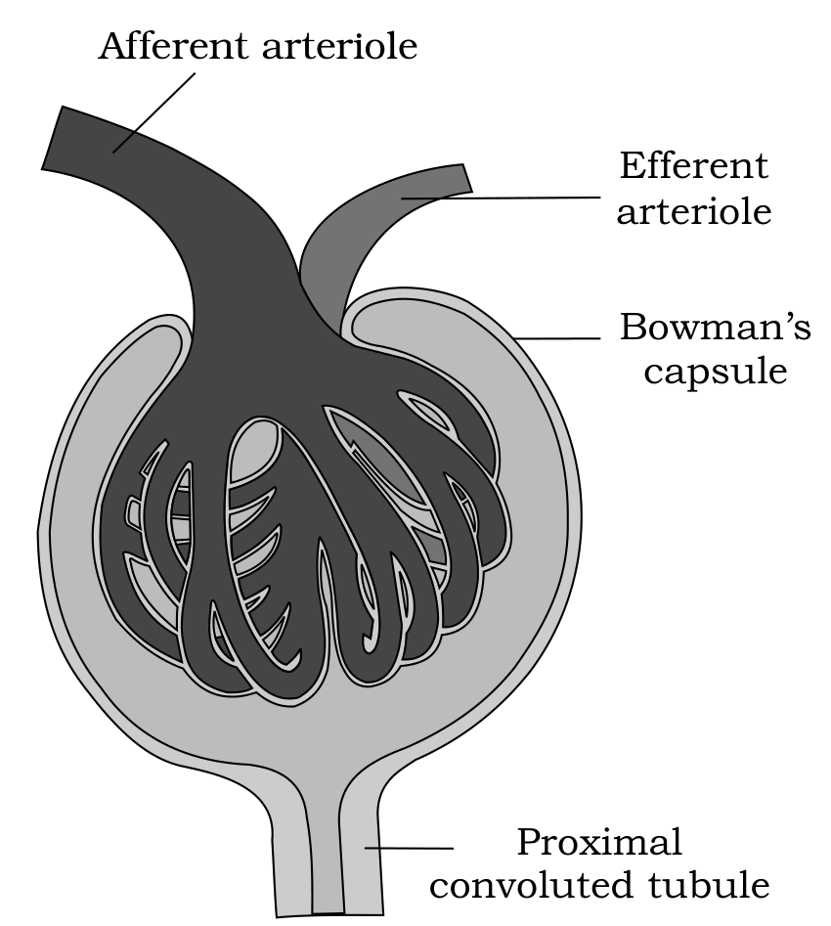
Figure 16.4 Malpighian body (renal corpuscle)
The renal tubule then runs through four named segments in strict order:
1 | Bowman's capsule - double walled, cup-like, encloses the glomerulus; the filtrate enters the tubule here.
2 | Proximal convoluted tubule (PCT) - the tubule continues to form a highly coiled network.
3 | Henle's loop - a hairpin shaped region with a descending and an ascending limb.
4 | Distal convoluted tubule (DCT) - the ascending limb continues as another highly coiled tubular region.
5 | Collecting duct - the DCTs of many nephrons open into a straight tube; many collecting ducts converge and open into the renal pelvis through the medullary pyramids in the calyces.

[NOTE] Which segment sits in which zone. The Malpighian corpuscle, PCT and DCT of the nephron are situated in the cortical region of the kidney, whereas the loop of Henle dips into the medulla. This single sentence is the anatomical basis of the whole of 16.4: only the loop and the collecting duct travel through the salty medulla, so only they can exploit its osmotic gradient.

16.1c | Two Kinds of Nephron

Feature | Cortical nephrons | Juxta medullary nephrons
Proportion | The majority of nephrons | Some of the nephrons
Loop of Henle | Too short; extends only very little into the medulla | Very long; runs deep into the medulla
Vasa recta | Absent or highly reduced | Present and well developed
Consequence | Limited ability to build a medullary gradient | Drive the counter current mechanism and concentrated urine (16.4)

The blood supply around the tubule has its own two named parts:
• The efferent arteriole emerging from the glomerulus forms a fine capillary network around the renal tubule called the peritubular capillaries.
• A minute vessel of this network runs parallel to Henle's loop, forming a 'U' shaped vasa recta.
• Vasa recta is absent or highly reduced in cortical nephrons - which is exactly why cortical nephrons cannot concentrate urine strongly.
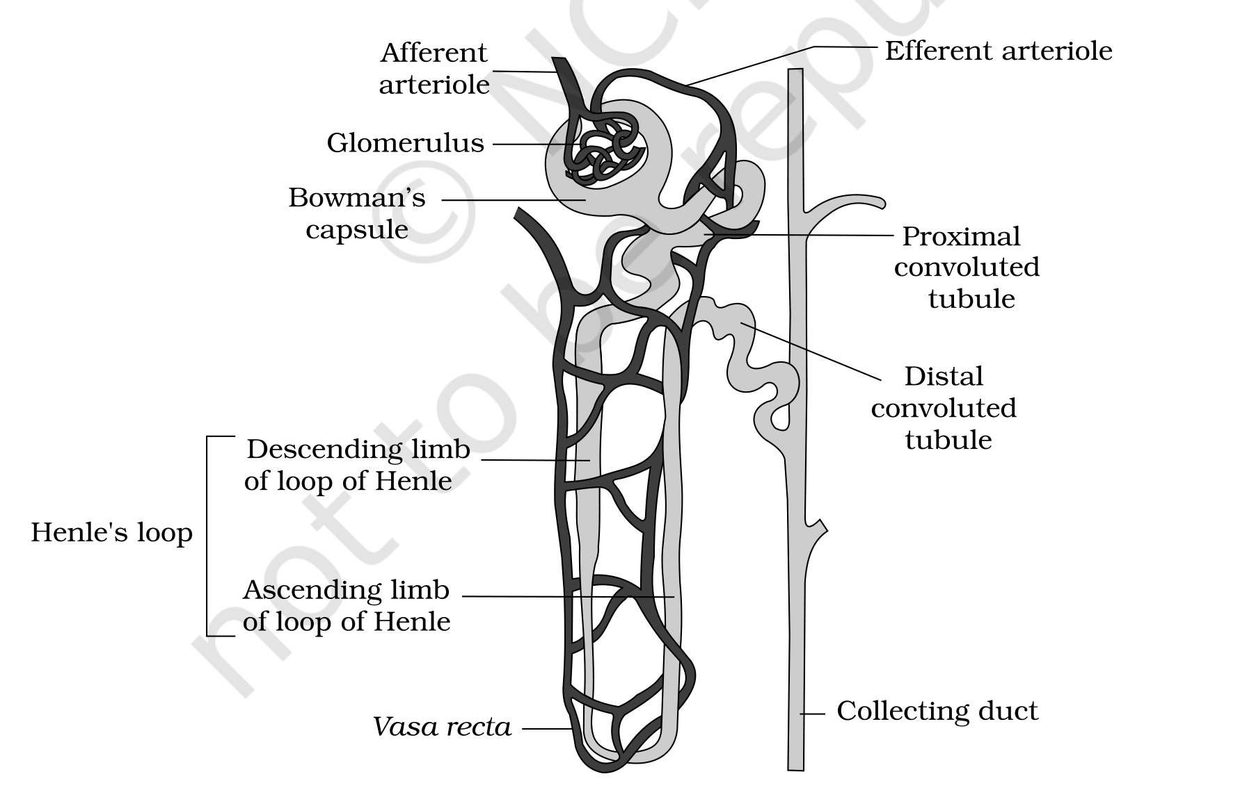
Figure 16.3 A diagrammatic representation of a nephron showing blood vessels, duct and tubule
[MEMORY AID - not in NCERT] Two arterioles, one capillary bed in between - the kidney's signature. Afferent Arrives, Efferent Exits. Because a capillary tuft lies between two arterioles (not between an arteriole and a vein), the kidney can hold glomerular pressure high enough to filter - and can adjust it. Exercise 11(c) asks for "a loop of capillary running parallel to the Henle's loop": vasa recta.

16.2 | URINE FORMATION

Urine formation involves three main processes, namely glomerular filtration, reabsorption and secretion, that take place in different parts of the nephron.
[MEMORY AID - not in NCERT] Urine = Filtered - Reabsorbed + Secreted. Keep that equation in view for the whole chapter. Filtration is bulk and indiscriminate; reabsorption claims back everything valuable; secretion actively dumps a short list of extras. Anything in your urine got there because it was either filtered and not reclaimed, or deliberately secreted.

16.2a | Glomerular Filtration

The first step in urine formation is the filtration of blood, which is carried out by the glomerulus and is called glomerular filtration. It is a non-selective process: the glomerulus does not choose what to let through, it simply uses the glomerular capillary blood pressure to push fluid across, and the membranes decide by size alone.
• On an average, 1100-1200 ml of blood is filtered by the kidneys per minute, which constitutes roughly 1/5th (one-fifth) of the blood pumped out by each ventricle of the heart in a minute.
The glomerular capillary blood pressure causes filtration of blood through 3 layers:
1 | The endothelium of the glomerular blood vessels.
2 | The epithelium of Bowman's capsule - its cells, called podocytes, are arranged in an intricate manner so as to leave some minute spaces called filtration slits or slit pores.
3 | A basement membrane lying between these two layers.

Blood is filtered so finely through these membranes that almost all the constituents of the plasma except the proteins pass into the lumen of the Bowman's capsule. The fluid that arrives in the capsule is therefore a protein-free fluid filtered from the blood plasma.
• Ultra filtration - because the filtration is fine enough to hold back essentially all plasma proteins while letting everything smaller through, glomerular filtration is considered a process of ultra filtration.
[NOTE] Two exam-critical consequences of "protein-free". (1) Proteins are retained, so plasma proteins stay in the blood and hold its osmotic pull - this is why proteinuria signals a damaged filtration barrier. (2) Glucose, amino acids and ions are not retained at the glomerulus - they are filtered freely and must be won back downstream by reabsorption. Filtration does not protect anything useful except protein; the tubules do all the saving.

• Glomerular filtration rate (GFR) - the amount of the filtrate formed by the kidneys per minute. [Exercise 1 asks exactly this.]
• GFR in a healthy individual is approximately 125 ml/minute, i.e., 180 litres per day!
Quantity | Value | Read it as
Blood filtered by the glomerulus | about 1100-1200 ml per minute | roughly 1/5th of the cardiac output
Filtrate formed in Bowman's capsule (GFR) | 125 ml per minute | 180 litres per day
Urine actually released | 1 to 1.5 litres per day | so nearly 99 per cent is reabsorbed

[MEMORY AID - not in NCERT] 1200 in, 125 out, 1.5 kept. About 1200 ml of blood per minute is filtered by the glomerulus to form 125 ml of filtrate per minute in Bowman's capsule (= GFR), and only about 1.5 litres leaves the body per day. Those three numbers, in that order, answer most numerical NEET items on this chapter.

16.2b | Autoregulation of GFR - the JGA

The kidneys have built-in mechanisms for the regulation of glomerular filtration rate. One such efficient mechanism is carried out by the juxta glomerular apparatus (JGA).
• Juxta glomerular apparatus (JGA) - a special sensitive region formed by cellular modifications in the distal convoluted tubule and the afferent arteriole at the location of their contact.
1 | (cycle - last step feeds back to step 1)
2 | GFR falls below normal.
3 | The fall activates the JG cells of the juxta glomerular apparatus.
4 | The JG cells release renin.
5 | Renin stimulates the glomerular blood flow, and thereby brings the GFR back to normal.

[NOTE] This is the short, local version of the story - the full hormonal cascade that renin sets off (angiotensin I, angiotensin II, aldosterone) is developed in 16.5. For Exercise 2, "the autoregulatory mechanism of GFR" means precisely this JGA loop: the kidney senses its own filtration rate at the DCT-afferent arteriole contact and corrects it without waiting for instructions from outside.

16.2c | Reabsorption

A comparison of the volume of the filtrate formed per day (180 litres per day) with that of the urine released (1.5 litres) suggests that nearly 99 per cent of the filtrate has to be reabsorbed by the renal tubules. This process is called reabsorption.
• The tubular epithelial cells in different segments of the nephron perform this either by active or passive mechanisms.
• For example, substances like glucose, amino acids and Na⁺ in the filtrate are reabsorbed actively, whereas the nitrogenous wastes are absorbed by passive transport.
• Reabsorption of water also occurs passively in the initial segments of the nephron (Figure 16.5).
16.2d | Tubular Secretion

During urine formation, the tubular cells secrete substances like H⁺, K⁺ and ammonia (NH₃) into the filtrate. Tubular secretion is also an important step in urine formation, as it helps in the maintenance of the ionic and acid-base balance of body fluids.

Process | Direction | Site | What moves
Glomerular filtration | Blood into the tubule (Bowman's capsule) | Glomerulus | Everything in plasma except proteins; non-selective, pressure driven
Reabsorption | Tubule back into the blood | All along the tubule; PCT is the major site | Glucose, amino acids, Na⁺ (active); nitrogenous wastes and water (passive); about 99% of the filtrate
Secretion | Blood/tubular cells into the tubule | PCT, DCT, collecting duct | H⁺, K⁺, NH₃; maintains ionic and acid-base balance

[MEMORY AID - not in NCERT] Do not confuse secretion with excretion. Secretion is a step inside the nephron - the tubule adds substances to the filtrate. Excretion is the final removal from the body. Also note that reabsorption and secretion run in opposite directions across the same tubular wall at the same time.

16.3 | FUNCTION OF THE TUBULES

Each segment of the renal tubule has its own permeability and its own transport specialities, and that is what makes graded processing of the filtrate possible. Read the four segments below as one assembly line.
PCT | Proximal Convoluted Tubule (PCT):

PCT is lined by simple cuboidal brush border epithelium, which increases the surface area for reabsorption.
• Nearly all of the essential nutrients, and 70-80 per cent of electrolytes and water, are reabsorbed by this segment. The PCT is therefore the major site of reabsorption and selective secretion.
• PCT also helps to maintain the pH and ionic balance of the body fluids by selective secretion of hydrogen ions (H⁺) and ammonia (NH₃) into the filtrate, and by absorption of HCO₃⁻ from it.
[NOTE] The brush border is the whole point of the PCT. Those microvilli multiply the membrane area available for carrier proteins, which is why the bulk of glucose, amino acids and electrolytes is recovered here and not later. Exercise 3(e) - glucose is actively reabsorbed in the proximal convoluted tubule - is true.

HL | Henle's Loop:

Reabsorption is minimum in its ascending limb. However, this region plays a significant role in the maintenance of high osmolarity of the medullary interstitial fluid.
The two limbs are mirror opposites in permeability, and this contrast is the engine of the counter current mechanism in 16.4:
 | Descending limb | Ascending limb
Permeable to water? | Permeable to water | Impermeable to water
Permeable to electrolytes? | Almost impermeable to electrolytes | Allows transport of electrolytes, actively or passively
Effect on the filtrate | Water leaves, so the filtrate gets concentrated as it moves down | Electrolytes leave, so the concentrated filtrate gets diluted as it passes upward
Effect on the interstitium | Adds water to the interstitium | Adds electrolytes, raising medullary osmolarity

• The descending limb of the loop of Henle is permeable to water but almost impermeable to electrolytes. This concentrates the filtrate as it moves down.
• The ascending limb is impermeable to water but allows transport of electrolytes actively or passively. Therefore, as the concentrated filtrate passes upward, it gets diluted due to the passage of electrolytes to the medullary fluid.
[NOTE] The ascending limb is not uniform along its length. Figure 16.5 labels both a thick segment of ascending limb and a thin segment of ascending limb, though the chapter's prose names only the thin one (in 16.4, where urea enters it). The distinction is worth holding: the thin segment lies deeper in the medulla and passes electrolytes and a little urea largely passively, whereas the thick segment carries the powerful active transport of NaCl out into the interstitium. Both are impermeable to water, which is why dilution of the filtrate continues all the way up.

[MEMORY AID - not in NCERT] Descending = water Departs. Ascending = salt Ascends out. So going down the filtrate gets saltier, coming up it gets more dilute - and the medulla gets saltier either way. For Exercise 12(a): the ascending limb is impermeable to water whereas the descending limb is permeable to it.

DCT | Distal Convoluted Tubule (DCT):

Conditional reabsorption of Na⁺ and water takes place in this segment. The word conditional is doing real work here: unlike the PCT's near-automatic bulk recovery, what the DCT reclaims depends on the body's current needs, under hormonal control (ADH and aldosterone, 16.5).
• DCT is also capable of reabsorption of HCO₃⁻ and selective secretion of hydrogen (H⁺) and potassium (K⁺) ions and NH₃, to maintain the pH and sodium-potassium balance in blood.
CD | Collecting Duct:

This long duct extends from the cortex of the kidney to the inner parts of the medulla. Because it crosses the entire osmotic gradient built by the loop of Henle, it is the segment where the final water decision is made.
• Large amounts of water could be reabsorbed from this region to produce a concentrated urine.
• This segment allows passage of small amounts of urea into the medullary interstitium, to keep up the osmolarity.
• It also plays a role in the maintenance of pH and ionic balance of blood by the selective secretion of H⁺ and K⁺ ions (Figure 16.5).
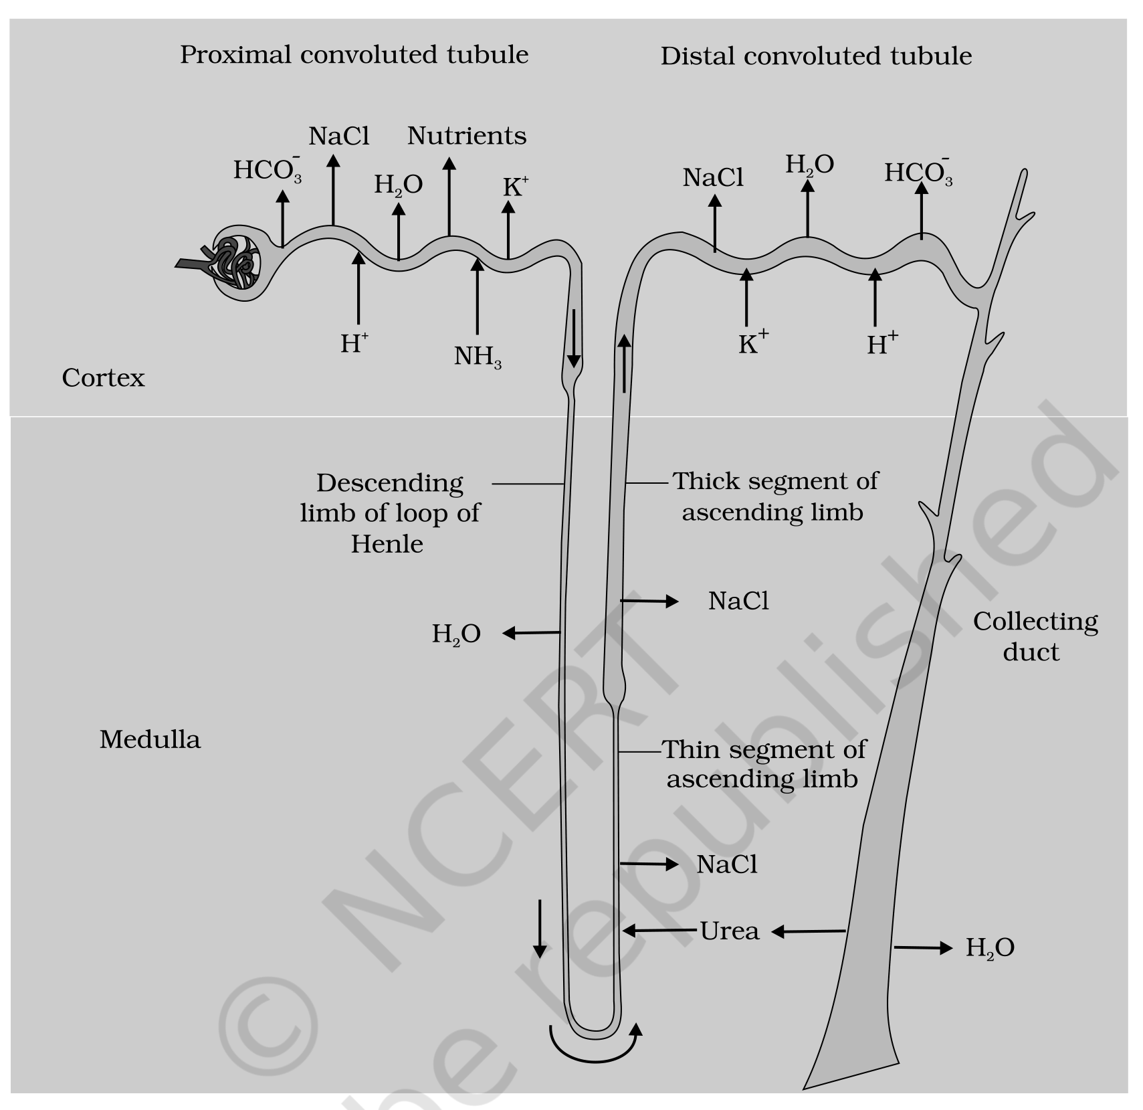
Figure 16.5 Reabsorption and secretion of major substances at different parts of the nephron (Arrows indicate direction of movement of materials.)
16.3s | Segment-by-Segment Summary of Tubular Function

Segment | Reabsorbs | Secretes | Signature fact
PCT | Nearly all essential nutrients; 70-80% of electrolytes and water; HCO₃⁻ | H⁺, NH₃ | Brush border epithelium; major site of reabsorption
Henle's loop - descending limb | Water (passively) | - | Impermeable to electrolytes; concentrates the filtrate
Henle's loop - ascending limb | Electrolytes (to interstitium); reabsorption of water is minimum | - | Impermeable to water; dilutes the filtrate, salts the medulla
DCT | Conditional Na⁺ and water; HCO₃⁻ | H⁺, K⁺, NH₃ | Hormone-controlled; sodium-potassium and pH balance
Collecting duct | Large amounts of water; allows urea into the interstitium | H⁺, K⁺ | Runs cortex to inner medulla; sets final urine concentration

[MEMORY AID - not in NCERT] PCT = bulk. Loop = gradient. DCT = fine tuning. Collecting duct = final water call. If a NEET question asks "where", match the verb: bulk/most/nutrients means PCT, osmolarity/gradient means loop of Henle, conditional/hormonal means DCT, concentrated urine means collecting duct.

16.4 | MECHANISM OF CONCENTRATION OF THE FILTRATE

Mammals have the ability to produce a concentrated urine. The Henle's loop and vasa recta play a significant role in this.
16.4a | Counter Current - What the Word Means

• The flow of filtrate in the two limbs of Henle's loop is in opposite directions, and thus forms a counter current.
• The flow of blood through the two limbs of vasa recta is also in a counter current pattern.
The proximity between the Henle's loop and vasa recta, as well as the counter current in them, help in maintaining an increasing osmolarity towards the inner medullary interstitium, i.e., from 300 mOsmolL⁻¹ in the cortex to about 1200 mOsmolL⁻¹ in the inner medulla. This gradient is mainly caused by NaCl and urea.
[NOTE] Why a counter current is worth the trouble. If both limbs flowed the same way, whatever one limb built up the other would immediately wash away, and the medulla would sit at blood osmolarity. Because they run opposite, each small transport step is handed over to a neighbouring stream that is only slightly different in concentration, and those small differences multiply along the length of the loop into a four-fold gradient from cortex to inner medulla. This is why the arrangement is often called a counter current multiplier, and why a long loop (juxta medullary nephron) concentrates urine better than a short one.

16.4b | The Counter Current Mechanism, Step by Step

1 | NaCl is transported by the ascending limb of Henle's loop, which is exchanged with the descending limb of vasa recta.
2 | NaCl is returned to the interstitium by the ascending portion of vasa recta - so the salt is recycled within the medulla instead of being carried away in the blood.
3 | Similarly, small amounts of urea enter the thin segment of the ascending limb of Henle's loop.
4 | That urea is transported back to the interstitium by the collecting tubule, completing a second recycling loop.
5 | The result is a standing gradient: electrolytes and urea are retained in the interstitium by this arrangement, holding the inner medulla near 1200 mOsmolL⁻¹.

• Counter current mechanism - the above described transport of substances facilitated by the special arrangement of Henle's loop and vasa recta (Figure. 16.6). [Exercise 4 asks for a brief account of exactly this.]
• This mechanism helps to maintain a concentration gradient in the medullary interstitium.
• Presence of such an interstitial gradient helps in an easy passage of water from the collecting tubule, thereby concentrating the filtrate (urine).
• Human kidneys can produce urine nearly four times concentrated than the initial filtrate formed - the DCT and collecting duct concentrate the filtrate from about 300 mOsmolL⁻¹ to 1200 mOsmolL⁻¹, an excellent mechanism of conservation of water.
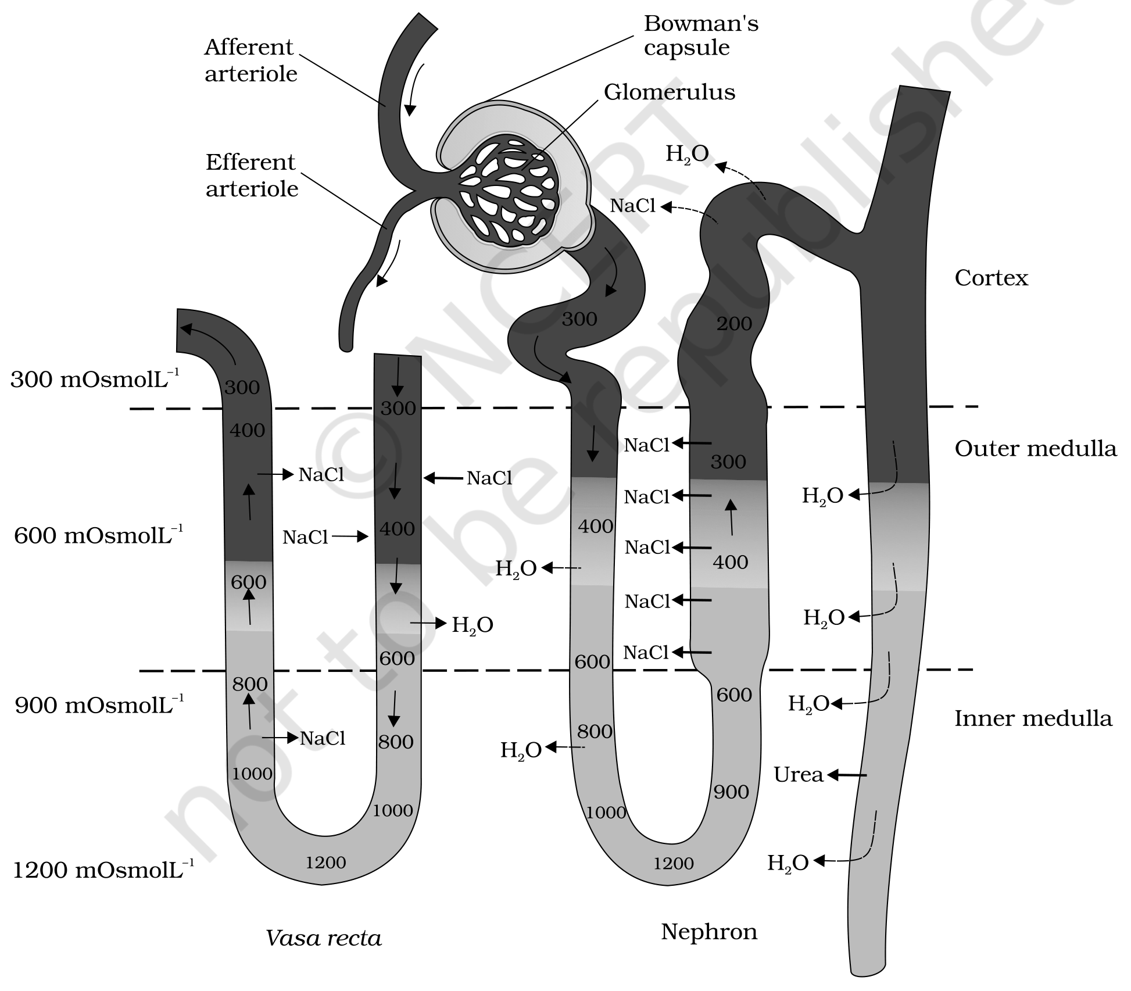
Figure 16.6 Diagrammatic representation of a nephron and vasa recta showing counter current mechanisms
[MEMORY AID - not in NCERT] 300 to 1200 = four times. Cortex sits at 300, inner medulla at 1200; that ratio is the "four times concentrated" fact. Remember the two solutes that build it - NaCl and urea - and the two structures that recycle them - Henle's loop and vasa recta. Salt is handed over by the loop and returned by vasa recta; urea leaks in from the collecting duct.

[NOTE] Putting 16.3 and 16.4 together. The loop of Henle does not concentrate the urine directly - the filtrate actually leaves the loop more dilute than it entered. What the loop does is make the medulla salty. The concentrated urine is then produced downstream, when the collecting duct carries filtrate back through that salty medulla and water is drawn out. For Exercise 3(d) - Henle's loop plays an important role in concentrating the urine - the answer is true, but understand it as an indirect role: it builds the gradient that the collecting duct spends.

16.5 | REGULATION OF KIDNEY FUNCTION

The functioning of the kidneys is efficiently monitored and regulated by hormonal feedback mechanisms involving the hypothalamus, the JGA and, to a certain extent, the heart.
16.5a | ADH and the Osmoreceptor Loop

1 | (cycle - last step feeds back to step 1)
2 | An excessive loss of fluid from the body activates the osmoreceptors in the body.
3 | These stimulate the hypothalamus to release antidiuretic hormone (ADH), also known as vasopressin, from the neurohypophysis.
4 | ADH facilitates water reabsorption from the latter parts of the tubule, thereby preventing diuresis.
5 | An increase in body fluid volume results, which switches off the osmoreceptors and suppresses the ADH release to complete the feedback.

• Diuresis - the loss of water (increased urine output) that ADH prevents. Because ADH is antidiuretic, more ADH means less urine and a more concentrated urine.
[NOTE] ADH's second job. ADH can also affect the kidney function by its constrictory effects on blood vessels. This causes an increase in blood pressure, and an increase in blood pressure increases the glomerular blood flow, and thereby the GFR. That is why the same hormone carries the alternative name vasopressin - one molecule, two levers: water retention at the tubule and vasoconstriction at the vessel.

[MEMORY AID - not in NCERT] ADH = Add water back to the blood. High ADH gives scanty, concentrated urine; no ADH gives copious, dilute urine (as in diabetes insipidus). So Exercise 3(b) - "ADH helps in water elimination, making the urine hypotonic" - is false; ADH does the exact opposite. Exercise 12(b): reabsorption of water from distal parts of the tubules is facilitated by ADH (vasopressin).

16.5b | The Renin-Angiotensin-Aldosterone System (RAAS)

The JGA plays a complex regulatory role. Here the trigger is not osmolarity but blood flow, blood volume and pressure reaching the kidney itself.
1 | (cycle - last step feeds back to step 1)
2 | A fall in glomerular blood flow / glomerular blood pressure / GFR can activate the JG cells to release renin.
3 | Renin converts angiotensinogen in blood to angiotensin I.
4 | Angiotensin I is further converted to angiotensin II.
5 | Angiotensin II, being a powerful vasoconstrictor, increases the glomerular blood pressure and thereby GFR.
6 | Angiotensin II also activates the adrenal cortex to release aldosterone.
7 | Aldosterone causes reabsorption of Na⁺ and water from the distal parts of the tubule.
8 | This also leads to an increase in blood pressure and GFR, restoring what the fall in step 1 had reduced.

• Renin-Angiotensin mechanism - this complex mechanism, operated by the JGA, is generally known as the Renin-Angiotensin mechanism.
[NOTE] Note that angiotensin II raises GFR two ways at once: directly, by constricting vessels and raising glomerular pressure, and indirectly, by ordering aldosterone which reclaims Na⁺ and water and so restores blood volume. Distinguish the two hormones carefully - ADH reabsorbs water alone, while aldosterone reabsorbs Na⁺ and water. Both act on "the distal parts of the tubule".

16.5c | ANF - the Opposing Signal

1 | An increase in blood flow to the atria of the heart occurs.
2 | This causes the release of Atrial Natriuretic Factor (ANF).
3 | ANF causes vasodilation (dilation of blood vessels).
4 | This decreases the blood pressure.

ANF mechanism, therefore, acts as a check on the renin-angiotensin mechanism. The kidney is thus held between two opposing hormonal pushes, which is what keeps blood pressure and fluid volume stable rather than oscillating.
Hormone | Source | Trigger | Main renal action | Net effect
ADH (vasopressin) | Hypothalamus, released from neurohypophysis | Excessive fluid loss activates osmoreceptors | Water reabsorption from the latter parts of the tubule; also vasoconstriction | Prevents diuresis; raises BP and GFR
Renin | JG cells of the JGA | Fall in glomerular blood flow / BP / GFR | Converts angiotensinogen to angiotensin I | Starts the RAAS cascade
Angiotensin II | Blood (from angiotensin I) | Renin release | Powerful vasoconstrictor; stimulates adrenal cortex | Increases glomerular BP and GFR
Aldosterone | Adrenal cortex | Angiotensin II | Reabsorption of Na⁺ and water from the distal parts of the tubule | Increases BP and GFR
ANF | Atria of the heart | Increased blood flow to the atria | Vasodilation | Decreases BP; a check on RAAS

[MEMORY AID - not in NCERT] Three sensors, three hormones. Osmoreceptors watch concentration and call ADH. JG cells watch renal blood flow and call renin (leading to angiotensin II and aldosterone). Atrial stretch watches volume and calls ANF. Four of the five hormones in the table raise BP or GFR; only ANF lowers it. If an exam option says "ANF increases blood pressure", it is wrong.

16.6 | MICTURITION

Urine formed by the nephrons is ultimately carried to the urinary bladder, where it is stored till a voluntary signal is given by the central nervous system (CNS). This signal is initiated by the stretching of the urinary bladder as it gets filled with urine.
• Micturition - the process of release of urine.
• Micturition reflex - the neural mechanisms causing micturition.
1 | Urine formed by the nephrons is carried to and stored in the urinary bladder.
2 | As the bladder fills, its stretching sends a signal, and stretch receptors on the wall of the bladder send signals to the CNS.
3 | The CNS passes on motor messages to initiate the contraction of the smooth muscles of the bladder and the simultaneous relaxation of the urethral sphincter, causing the release of urine.

[NOTE] The two events in step 3 must happen together - contraction of the bladder wall and relaxation of the sphincter. A NEET distractor often flips the sphincter to "contraction". Note also the hybrid nature of the act: the reflex is involuntary, but it waits on a voluntary signal from the CNS, which is why toilet training is possible at all. For Exercise 3(a) - micturition is carried out by a reflex - the answer is true.

An adult human excretes, on an average, 1 to 1.5 litres of urine per day. Its properties are:
• The urine formed is a light yellow coloured watery fluid.
• It is slightly acidic (pH 6.0).
• It has a characteristic odour.
• On an average, 25-30 gm of urea is excreted out per day. [Exercise 12(d) asks for this figure.]
[NOTE] Various conditions can affect the characteristics of urine, and this is precisely why urine analysis is a diagnostic tool. Analysis of urine helps in clinical diagnosis of many metabolic disorders as well as malfunctioning of the kidney. For example, presence of glucose (glycosuria) and ketone bodies (ketonuria) in urine are indicative of diabetes mellitus.

[MEMORY AID - not in NCERT] Urine numbers to keep: 1-1.5 L per day, pH 6.0, 25-30 g urea per day. And remember that glycosuria + ketonuria = diabetes mellitus, not a kidney disease - the kidney is reporting a metabolic problem elsewhere.

16.7 | ROLE OF OTHER ORGANS IN EXCRETION

Other than the kidneys, lungs, liver and skin also help in the elimination of excretory wastes. [Exercise 5 asks for exactly this account.]
Organ | What it eliminates | Notes
Lungs | Large amounts of CO₂ (approximately 200 mL/minute) and significant quantities of water every day | The single largest route for carbon dioxide
Liver | Bilirubin, biliverdin, cholesterol, degraded steroid hormones, vitamins and drugs | The largest gland in our body; secretes bile, containing these substances. Most of them pass out along with digestive wastes
Sweat glands (skin) | NaCl, small amounts of urea, lactic acid, etc. | Sweat's primary function is to facilitate a cooling effect on the body surface; excretion is only incidental
Sebaceous glands (skin) | Sterols, hydrocarbons and waxes through sebum | This secretion provides a protective oily covering for the skin

[NOTE] Both skin glands are worth reading carefully, because in each case excretion is a side effect of the gland's real job - cooling for sweat glands, oiling the skin for sebaceous glands. Note too that small amounts of nitrogenous wastes could be eliminated through saliva, which is the fifth and least-remembered accessory route.

[MEMORY AID - not in NCERT] Accessory excretory organs: Lungs, Liver, Skin (and a little saliva). Match each to its signature waste - lungs = CO₂, liver = bile pigments (bilirubin, biliverdin), sweat = NaCl, sebum = sterols and waxes. Sweat is the one that also carries a little urea.

16.8 | DISORDERS OF THE EXCRETORY SYSTEM

Malfunctioning of the kidneys can lead to accumulation of urea in blood, a condition called uremia, which is highly harmful and may lead to kidney failure. In such patients, urea can be removed by a process called haemodialysis.
16.8a | Haemodialysis - How the Artificial Kidney Works

1 | Blood drained from a convenient artery is pumped into a dialysing unit after adding an anticoagulant like heparin.
2 | The unit contains a coiled cellophane tube surrounded by the dialysing fluid, which has the same composition as that of plasma except the nitrogenous wastes.
3 | The porous cellophane membrane of the tube allows the passage of molecules based on concentration gradient.
4 | As nitrogenous wastes are absent in the dialysing fluid, these substances freely move out, thereby clearing the blood.
5 | The cleared blood is pumped back to the body through a vein after adding anti-heparin to it.

This method is a boon for thousands of uremic patients all over the world.
[NOTE] This is an artificial kidney. The design is elegant because it is subtractive: by making the dialysing fluid identical to plasma except for the wastes, only the wastes have a gradient to follow, so nothing valuable is lost. Note the two drug steps that bracket the procedure - heparin going in to stop clotting in the machine, anti-heparin coming out to restore normal clotting. Exercise 12(c): dialysis fluid contains all the constituents as in plasma except the nitrogenous wastes.

Kidney transplantation is the ultimate method in the correction of acute renal failures (kidney failure).
• A functioning kidney is used in transplantation from a donor, preferably a close relative, to minimise its chances of rejection by the immune system of the host.
• Modern clinical procedures have increased the success rate of such a complicated technique.
16.8b | Other Kidney Disorders

Disorder | Definition
Uremia | Accumulation of urea in blood due to malfunctioning of the kidneys; highly harmful, may lead to kidney failure
Renal calculi | Stone or insoluble mass of crystallised salts (oxalates, etc.) formed within the kidney
Glomerulonephritis | Inflammation of glomeruli of kidney

[MEMORY AID - not in NCERT] Locate each disorder by its word root. Ur-emia = urea in the blood; calculi = stones (Latin for pebble, as in "calculate" with pebbles); glomerulo-nephritis = inflammation (-itis) of the glomeruli. Treatment ladder for failure: haemodialysis first, kidney transplantation as the ultimate correction.

S | SUMMARY

Many nitrogen containing substances, ions, CO₂, water, etc., that accumulate in the body have to be eliminated. Nature of nitrogenous wastes formed and their excretion vary among animals, mainly depending on the habitat (availability of water). Ammonia, urea and uric acid are the major nitrogenous wastes excreted. Protonephridia, nephridia, malpighian tubules, green glands and the kidneys are the common excretory organs in animals. They not only eliminate nitrogenous wastes but also help in the maintenance of ionic and acid-base balance of body fluids.
In humans, the excretory system consists of one pair of kidneys, a pair of ureters, a urinary bladder and a urethra. Each kidney has over a million tubular structures called nephrons. Nephron is the functional unit of kidney and has two portions - glomerulus and renal tubule. Glomerulus is a tuft of capillaries formed from afferent arterioles, fine branches of renal artery. The renal tubule starts with a double walled Bowman's capsule and is further differentiated into a proximal convoluted tubule (PCT), Henle's loop (HL) and distal convoluted tubule (DCT). The DCTs of many nephrons join to a common collecting duct, many of which ultimately open into the renal pelvis through the medullary pyramids. The Bowman's capsule encloses the glomerulus to form Malpighian or renal corpuscle.
Urine formation involves three main processes, i.e., filtration, reabsorption and secretion. Filtration is a non-selective process performed by the glomerulus using the glomerular capillary blood pressure. About 1200 ml of blood is filtered by the glomerulus per minute to form 125 ml of filtrate in the Bowman's capsule per minute (GFR). JGA, a specialised portion of the nephrons, plays a significant role in the regulation of GFR. Nearly 99 per cent reabsorption of the filtrate takes place through different parts of the nephrons. PCT is the major site of reabsorption and selective secretion. HL primarily helps to maintain the osmolar gradient (300 mOsmolL⁻¹ - 1200 mOsmolL⁻¹) within the kidney interstitium. DCT and collecting duct allow extensive reabsorption of water and certain electrolytes, which help in osmoregulation: H⁺, K⁺ and NH₃ could be secreted into the filtrate by the tubules to maintain the ionic balance and pH of body fluids.
A counter current mechanism operates between the two limbs of the loop of Henle and those of vasa recta (capillary parallel to Henle's loop). The filtrate gets concentrated as it moves down the descending limb but is diluted by the ascending limb. Electrolytes and urea are retained in the interstitium by this arrangement. DCT and collecting duct concentrate the filtrate about four times, i.e., from 300 mOsmolL⁻¹ to 1200 mOsmolL⁻¹, an excellent mechanism of conservation of water. Urine is stored in the urinary bladder till a voluntary signal from CNS carries out its release through urethra, i.e., micturition. Skin, lungs and liver also assist in excretion.
E | EXERCISES

[NOTE] All twelve NCERT exercises are reproduced below with worked answers. Every answer is sourced from the chapter text above; where the chapter never states a needed definition (osmoregulation, Exercise 8) or never explains a required reason (Exercise 9), the answer is derived from what the chapter does say, and that is flagged in place.

1. Define Glomerular Filtration Rate (GFR).
Answer. GFR is the amount of the filtrate formed by the kidneys per minute. In a healthy individual it is approximately 125 ml/minute, i.e., about 180 litres per day.
2. Explain the autoregulatory mechanism of GFR.
Answer. The kidney regulates its own GFR through the juxta glomerular apparatus (JGA) - a sensitive region formed by cellular modifications in the distal convoluted tubule and the afferent arteriole at their point of contact. A fall in GFR activates the JG cells to release renin, which stimulates the glomerular blood flow and thereby brings the GFR back to normal. In its fuller form (16.5), renin converts angiotensinogen to angiotensin I and then to angiotensin II, a powerful vasoconstrictor that increases glomerular blood pressure and GFR, and which also stimulates the adrenal cortex to release aldosterone, causing reabsorption of Na⁺ and water from the distal tubule - again raising blood pressure and GFR.
3. Indicate whether the following statements are true or false:
• (a) Micturition is carried out by a reflex. - TRUE. Stretch receptors on the bladder wall signal the CNS, which sends motor messages causing contraction of the bladder's smooth muscles and simultaneous relaxation of the urethral sphincter.
• (b) ADH helps in water elimination, making the urine hypotonic. - FALSE. ADH is antidiuretic: it facilitates water reabsorption from the latter parts of the tubule and prevents diuresis, making the urine hypertonic (concentrated), not hypotonic.
• (c) Protein-free fluid is filtered from blood plasma into the Bowman's capsule. - TRUE. Almost all constituents of plasma except the proteins pass into the lumen of the Bowman's capsule; hence glomerular filtration is called ultra filtration.
• (d) Henle's loop plays an important role in concentrating the urine. - TRUE. Its role is indirect but essential: the loop maintains the high osmolarity of the medullary interstitium, and that gradient is what lets water leave the collecting duct.
• (e) Glucose is actively reabsorbed in the proximal convoluted tubule. - TRUE. Substances like glucose, amino acids and sodium are reabsorbed actively, and the PCT with its brush border epithelium is the major site of reabsorption.
4. Give a brief account of the counter current mechanism.
Answer. The flow of filtrate in the two limbs of Henle's loop is in opposite directions, and so is the flow of blood in the two limbs of vasa recta - hence a counter current. Their proximity plus this opposing flow maintains an increasing osmolarity towards the inner medullary interstitium, from about 300 mOsmolL⁻¹ in the cortex to 1200 mOsmolL⁻¹ in the inner medulla, a gradient caused mainly by NaCl and urea. NaCl is transported by the ascending limb of Henle's loop and exchanged with the descending limb of vasa recta; it is then returned to the interstitium by the ascending portion of vasa recta. Similarly, small amounts of urea enter the thin segment of the ascending limb and are transported back to the interstitium by the collecting tubule. Electrolytes and urea are thus retained in the interstitium, and this gradient permits easy passage of water out of the collecting tubule - letting human kidneys produce urine nearly four times concentrated than the initial filtrate.
5. Describe the role of liver, lungs and skin in excretion.
• Lungs remove large amounts of CO₂ (approximately 200 mL/minute) and significant quantities of water every day.
• Liver, the largest gland in the body, secretes bile containing bilirubin, biliverdin, cholesterol, degraded steroid hormones, vitamins and drugs. Most of these pass out along with digestive wastes.
• Skin excretes through two gland types. Sweat glands remove NaCl, small amounts of urea, lactic acid, etc., though sweat's primary function is cooling the body surface. Sebaceous glands eliminate sterols, hydrocarbons and waxes through sebum, which provides a protective oily covering for the skin.
6. Explain micturition.
Answer. Micturition is the process of release of urine, and the neural mechanisms causing it constitute the micturition reflex. Urine formed by the nephrons is carried to the urinary bladder, where it is stored till a voluntary signal is given by the CNS. That signal is initiated by the stretching of the urinary bladder as it fills: stretch receptors on the bladder wall send signals to the CNS, and the CNS passes on motor messages that cause contraction of the smooth muscles of the bladder with simultaneous relaxation of the urethral sphincter, releasing the urine. An adult human excretes 1 to 1.5 litres of urine per day.
7. Match the items of column I with those of column II:
Column I | Column II | Match
(a) Ammonotelism | (i) Birds | (iii) Bony fish
(b) Bowman's capsule | (ii) Water reabsorption | (v) Renal tubule
(c) Micturition | (iii) Bony fish | (iv) Urinary bladder
(d) Uricotelism | (iv) Urinary bladder | (i) Birds
(d) ADH | (v) Renal tubule | (ii) Water reabsorption

[NOTE] The second-last and last items are both numbered "(d)" in the NCERT source; the numbering is reproduced verbatim above. Read the fifth row as (e) ADH. So the key is (a)-(iii), (b)-(v), (c)-(iv), (d)-(i), (e)-(ii).

8. What is meant by the term osmoregulation?
Answer. Osmoregulation is the maintenance of a constant water and electrolyte (ionic) balance in the body fluids - regulation of the osmotic concentration of those fluids - so that cells are neither swollen by excess water nor shrunken by its loss. In humans the DCT and collecting duct allow extensive reabsorption of water and certain electrolytes, which is what achieves osmoregulation, under the control of ADH and aldosterone. In many invertebrates it is the chief job of the excretory organs: protonephridia in Planaria are used primarily for osmoregulation, and nephridia and malpighian tubules also maintain fluid and ionic balance.
[NOTE] Source gap. The chapter uses "osmoregulation" in 16.0, 16.3 and the Summary but never defines it, although this exercise demands the definition. The definition above is supplied from standard usage and tied back to what the chapter does state.

9. Terrestrial animals are generally either ureotelic or uricotelic, not ammonotelic, why?
Answer. Because ammonia is the most toxic of the three nitrogenous wastes and requires a large amount of water for its elimination, whereas uric acid, being the least toxic, can be removed with a minimum loss of water. A terrestrial animal has only limited water available and cannot afford to lose that much of it, so terrestrial adaptation necessitated the production of lesser toxic nitrogenous wastes like urea and uric acid for the conservation of water. Ureotelic animals convert ammonia into urea in the liver and excrete it via the kidneys; uricotelic animals excrete uric acid as a pellet or paste, which is the driest option of all. Ammonotelic excretion, by contrast, depends on diffusion across body or gill surfaces into surrounding water - a route simply not available on land.
10. What is the significance of juxta glomerular apparatus (JGA) in kidney function?
Answer. The JGA is a specialised, sensitive region formed by cellular modifications in the distal convoluted tubule and the afferent arteriole at their point of contact, and it plays a significant role in the regulation of GFR. It is the kidney's own autoregulatory device: a fall in glomerular blood flow, glomerular blood pressure or GFR activates the JG cells to release renin, which triggers the renin-angiotensin mechanism - angiotensinogen to angiotensin I, then angiotensin II, a powerful vasoconstrictor that raises glomerular blood pressure and GFR, and which also makes the adrenal cortex release aldosterone, causing reabsorption of Na⁺ and water from the distal tubule. The net effect is restoration of blood pressure and GFR - held in check by ANF from the atria, which causes vasodilation and lowers blood pressure.
11. Name the following:
• (a) A chordate animal having flame cells as excretory structures - Amphioxus (the cephalochordate). Flame cells, or protonephridia, also occur in Platyhelminthes such as Planaria, in rotifers and in some annelids, but among those only Amphioxus is a chordate.
• (b) Cortical portions projecting between the medullary pyramids in the human kidney - Columns of Bertini (the renal columns).
• (c) A loop of capillary running parallel to the Henle's loop - vasa recta (a 'U' shaped minute vessel of the peritubular capillary network; absent or highly reduced in cortical nephrons).
12. Fill in the gaps:
• (a) Ascending limb of Henle's loop is impermeable to water whereas the descending limb is permeable to it.
• (b) Reabsorption of water from distal parts of the tubules is facilitated by hormone ADH (antidiuretic hormone, vasopressin).
• (c) Dialysis fluid contains all the constituents as in plasma except the nitrogenous wastes (e.g., urea).
• (d) A healthy adult human excretes (on an average) 25-30 gm of urea/day.

